**NAME**:A.JOICE MARY

**REG NO**:815120106007

**COLLEGE**:8151-DHANALAKSHMI SRINIVASAN INSTITUTE OF TECHNOLOGY SAMAYAPURAM TRICHY.

**NAAN MUDHALVAN COURSE**:DIGITAL MARKETING

**NMID**:A76356BEE6564EE8D5C48CC9FCBFA6C7

**ASSIGNMENT ON DIGITAL MARKETING**

**1.Create a blog or website using blogspot and wordpress.**

**Customize the theme design and post new atricle with 500 words.**

[**https://wordpress.com/post/cornarq.wordpress.com/13**](https://wordpress.com/post/cornarq.wordpress.com/13)

**2.Create a New Facebook Business Page and post one Social media poster for your brand.**

[**https://www.facebook.com/CornarQ?mibextid=ZbWKwL**](https://www.facebook.com/CornarQ?mibextid=ZbWKwL)

**3.Create a design a Social media advertisement poster using canva**

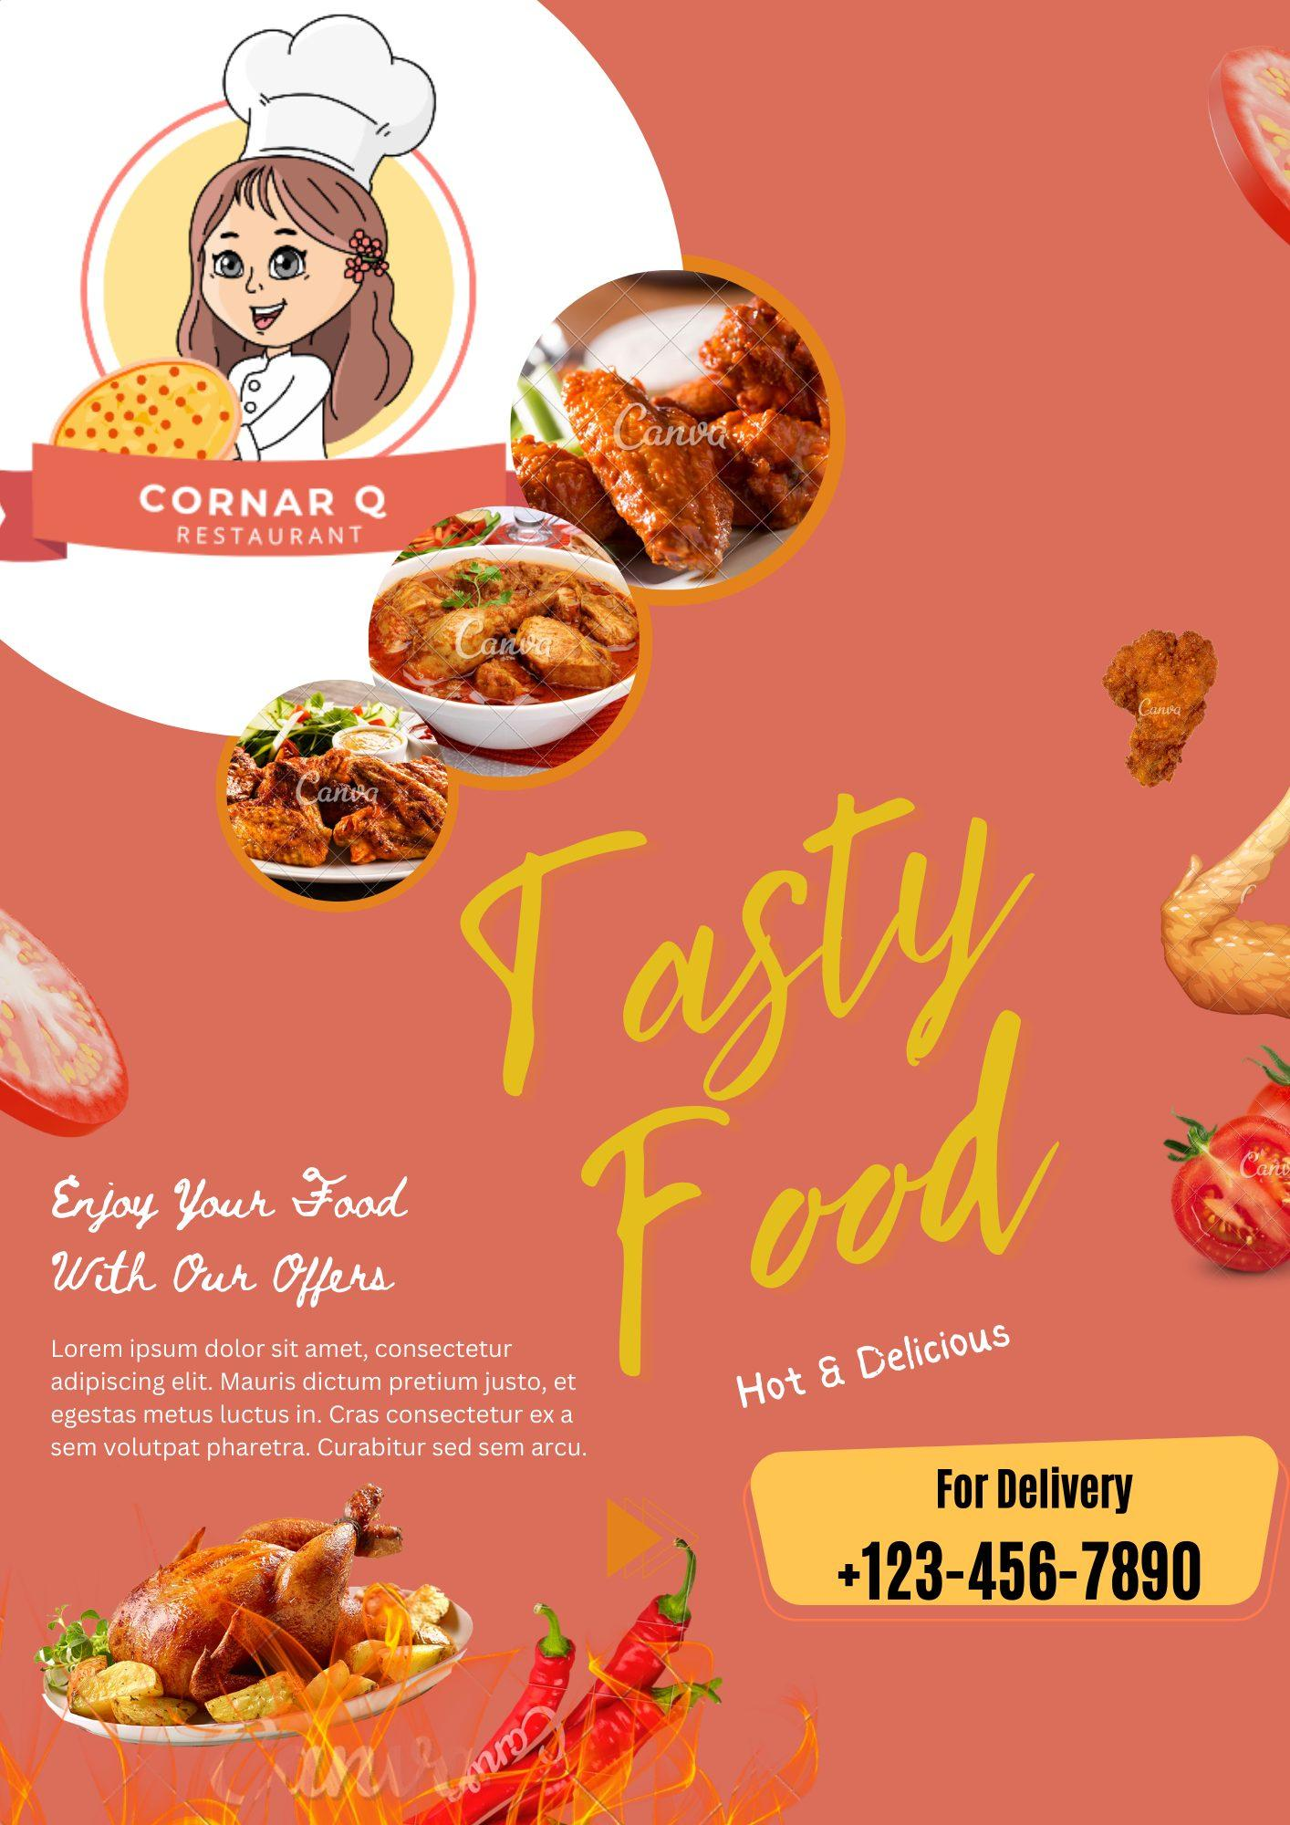

**4.Create email news letter design using Mailchimp or canva tool.**

